ATSIKANA PAULENDO PRIVATE SECONDARY SCHOOL

2021 MALAWI SCHOOL CERTIFICATE OF EDUCATION MOCK EXAMINATION

BIOLOGY
PAPER I
(100 marks)
Friday, 10 September Subject Number: M022/I
Time Allowed: 2 hrs
7:00 a.m. – 09:00 a.m.
Instructions:
- This paper contains 12 pages. Please check.

Question Number | Tick if Answered | Do not write in these margins
1
2
3
4
5
6
7
8
9
10
11
12
13
14
15
16
17
18

- Fill in your Examination number at the top of each page.

- Answer all the eighteen questions in the spaces provided.

- The maximum number of marks for each answer is
indicated against each question.

- In the table provided on this page, tick against the
question number you have answered.

- Hand in your paper to the invigilator when time is
called to stop writing.

SECTION A (70 marks)
- a. Define ‘Evolution’
________________________________________________________________________________________________________________________________________________________________ (1 mark)
b. Explain briefly how Geographical isolation can result in speciation
________________________________________________________________________________________________________________________________________________________________(1 mark)
c. How does Embryology support the theory of evolution?
________________________________________________________________________________________________________________________________________________________________(1 mark)
d. How fast running zebras develop from slow running zebras in an environment where there lions that are predators to zebras
_______________________________________________________________________________________________________________________________________________________________ (1 mark)
e. Fansidar was used to treat malaria in the past years and now there is RA.
(i) Name an example of natural selection above
____________________________________________________________________________ (1 mark)
(ii) How can new plasmodium develop in this case?
_______________________________________________________________________________________________________________________________________________________________ (1 mark)
2 a . Define the following terms:
(i) Blood typing
________________________________________________________________________________________________________________________________________________________________ (1 mark)
(ii) Transgenic organism
________________________________________________________________________________________________________________________________________________________________ (1 mark)
b. State two ways in which biotechnology can be applied.
_________________________________________________________________________________________________________________________________________________________________ (2 marks)
C . Give two ethical challenges of biotechnology.
_________________________________________________________________________________________________________________________________________________________________ (2 marks)
3. A female fruit fly with red eyes was crossed with purpled eyed mutant male and all their offspring’s in F1 were red-eyed. The offspring’s in F1 were mated among themselves and the following proportions of flies were produced 224 red eyed and 76 purple-eyed.
a. Using suitable symbols; explain the cross among the F1.

(4 marks)
b. State how you would determine the genotypes of red-eyed offspring’s of F2.
______________________________________________________________________________(1 mark)
c. Determine the number of heterozygous Red-eyed: _____________________________________________________________________________ (1 mark)

4. Figure 1 shows the life cycle of a worm. Use it to answer the questions that follow.

Z
X
Y

a. Name the worm infection
_______________________________________________________________________________ (1mark)
b. Identify the secondary host of the worm
_______________________________________________________________________________ (1mark)

c. Explain two ways of preventing worm infection
i.______________________________________________________________________________ (1 mark)
ii_____________________________________________________________________________ (1 mark)
5. Figure 2 shows a longitudinal section through the human ear. Use it to answer the questions that follow.
B

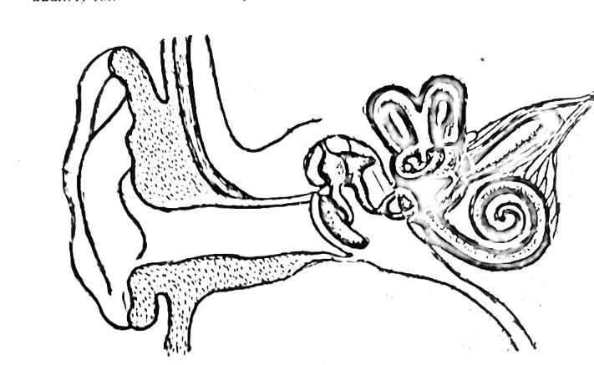
D
C
A

a. Name the parts labelled A and B.
A_________________________________________________________________________ (1mark)
B_________________________________________________________________________ (1mark)
b. Give the function of part D
__________________________________________________________________________ (1mark)
c.i Name the problem in which can occur if part C is damaged.
__________________________________________________________________________ (1mark)
ii. Explain one way of correcting the problem.
__________________________________________________________________________ (1 mark)

6.a. Figure 3 shows response in a potted plant which was placed horizontally. Use it to answer the questions that follow:

i. What was the stimulus in this experiment? _____________________________________________________________________________ (1 mark)
ii. Explain how the response in B above was brought about ____________________________________________________________________________________________________________________________________________________________________ (1 mark)
b. Briefly explain how human insulin is produced ___________________________________________________________________________________________________________________________________________________________________ (2 marks)
7. Figure 4 shows the sample of human red blood cells. Use it to answer questions that follow.

i. Name the genetic disease shown in the sample of human red blood cells above. _______________________________________________________________________________ 1 mark
ii. Give a reason for your answer in (i) above _______________________________________________________________________________ 1 mark
iii. State the advantage that people with this kind of genetic disease have over others ________________________________________________________________________________1mark
iv. Explain how maize weevils may develop resistance to pesticides ______________________________________________________________________________ (1 mark)
8. Figure 5 below represents a food web that would exist in a tropical savannah woodland ecosystem. Use it to answer the questions that follow.
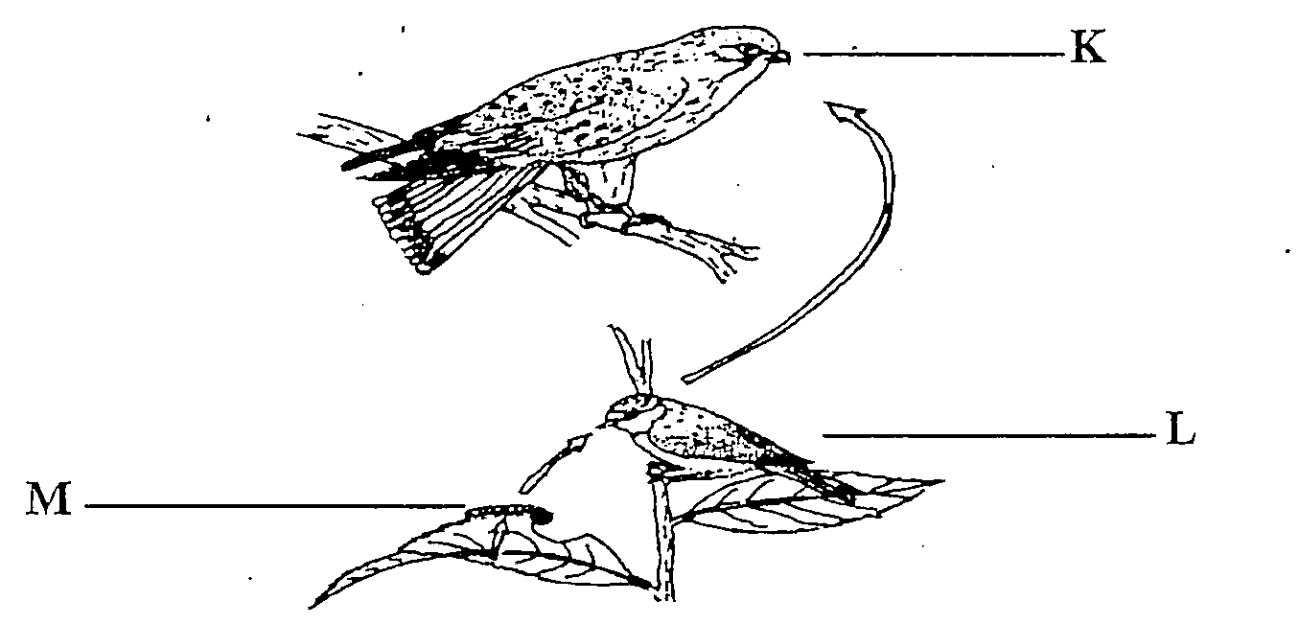
a. Name the type of relationship in the figure above
____________________________________________________________________________(1 mark)
b. Mention the
(i) Herbivore______________________________________________________________________(1 mark)
(ii) Carnivore_____________________________________________________________________ (1 mark)
c. (i)State any one adaptation of organism K to survive in this relationship
_____________________________________________________________________________________________________________________________________________________________________(1 mark)
(ii) Explain briefly how organism K would be affected if the population of of organism M was reduced
_________________________________________________________________________________ (1 mark)
d. Apart from pesticides, state any one way of reducing the population of organism M
_________________________________________________________________________________(1 mark)
9. Figure 6 shows three seedlings X, Y, Z placed in a box painted black and with a hole on one side. The seedlings were treated differently. Use it to answer questions that follow.
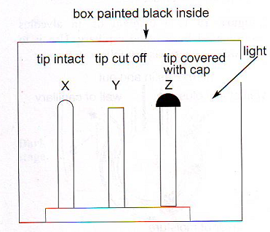
a). Why was the box painted black inside?
_____________________________________________________________________________ (1 mark)
b). In the box provided below, draw the seedling to show the results at the end of the experiment.

c). Explain the results in seedling Y
________________________________________________________________________________________________________________________________________________________________________(1mark)
10. Figure 7 below shows a lymph node which has a tumour beginning to develop. Use it to answer questions that follow.
a. Name the disease above
________________________________________________________________________________ (1 mark)

b. State any one ways in which tumour might affect cells surrounding it
________________________________________________________________________________ (1 mark)

c. Suggest any two factors that would increase the risk of developing the disease mentioned above
_______________________________________________________________________________________________________________________________________________________________________ (2 marks)
11. The diagram below shows the nitrogen cycle
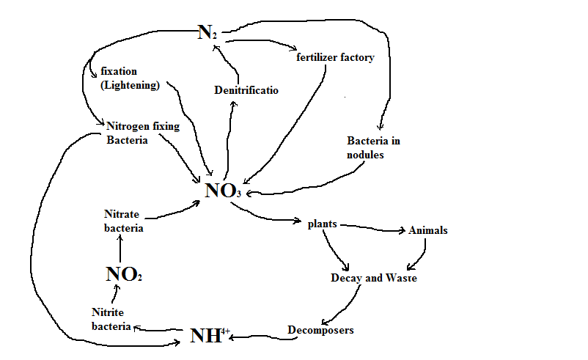

(a) Why is nitrogen important to living organisms?
_______________________________________________________________________________________________________________________________________________________________ (1 mark)
(b) In what form does each of the following obtain their nitrogen?
- Green plant _______________________________________________________________(1 mark)
- Animals: _________________________________________________________________(1 mark)
(c) Explain how does lightening help in nitrogen fixation
___________________________________________________________________________________________________________________________________________________________________ (2 marks)
12. Below is a diagram of an alveolous surrounded by the capillary. Use it to answer the questions that follow.
a. To which chamber of the heart does blood flow from point S
______________________________________________________________________________(1 mark)
b. Explain why there is a difference inthe amounts of oxygen between points T and S
____________________________________________________________________________________________________________________________________________________________________(1 mark)
c. Explain the role of a thin layer of moisture in the alveolus
______________________________________________________________________________(1 mark )
13. a. What is the advantage of the following in locommotion
(i). Overlapping of scale in fish
_________________________________________________________________________________(1 mark)
(ii). Hollow bones in birds
_________________________________________________________________________________(1 mark)
b. Explain how does the skeleton of animals help the following:
(i) Locomotion
_________________________________________________________________________________________________________________________________________________________________________(1 mark)
(ii) Protection
_____________________________________________________________________________________________________________________________________________________________________(1 mark)
14. Figure 8 below shows a nerve cell. Use it to answer the questions that follow.
a. Name the parts marked T and S
T_____________________________________________________________________________(1 mark)
S_____________________________________________________________________________(1 mark)
b. Name the type of the nerve cell shown in the figure above
______________________________________________________________________________(1 mark)
c. Explain what could happen if cell body was damaged
___________________________________________________________________________________________________________________________________________________________________(1 mark)
d. Explain any one adaptation that enables the nerve cell to conduct impulsesat high speed
__________________________________________________________________________________________________________________________________________________________________(1 mark)
15. a. Define the term Vaccine
__________________________________________________________________________________________________________________________________________________________________(1 mark)
b. How does HIV weaken the immune system in the body
___________________________________________________________________________________________________________________________________________________________________(2 marks )
b. Children under five years of age are vaccinated against diseases such as tetanus and tuberculosis.

(i) Explain how vaccination protects children against infection
___________________________________________________________________________________________________________________________________________________________________(2 marks)
(ii) Why can a vaccine for tetanus not be used against tuberculosis
________________________________________________________________________________________________________________________________________________________________________ (1 mark)

SECTION B (30 marks)
16. Suppose you are a District Health Officer in an area where there is cholera outbreak. Explain any five ways you can advise people in the community to use in order to prevent such a disease.
_____________________________________________________________________________________________________________________________________________________________________________________________________________________________________________________________________________________________________________________________________________________________________________________________________________________________________________________________________________________________________________________________________________________________________________________________________________________________________________________________________________________________________________________________________________________________________________________________________________________________________________________________________________________________________________________________________________________________________________________________________________________________________________________________________________________________________________________________________________________________________________________________________________________________________________________________________________________________________________________________________________________________________________________________________________________________________________________________________________________________________________________________________________________________________________________________________________________________________________________________________________________________________________________________________________________________________________________________________________________________________________________________________________________________________________________________________________________________________________________________________________________________________________________________________________________________________________________________________________________________________________________________________________________________________________________________________________________________________________________________________________________________________________________________________________________________________________________________________________________________________________________________________________________________________________________________________________________________________________ (10 marks)
17. Describe an experiment that could be conducted to show that germinating bean seeds contain an enzyme that digests starch. Your answer should include materials, procedure, expected results and conclusions.
______________________________________________________________________________________________________________________________________________________________________________________________________________________________________________________________________________________________________________________________________________________________________________________________________________________________________________________________________________________________________________________________________________________________________________________________________________________________________________________________________________________________________________________________________________________________________________________________________________________________________________________________________________________________________________________________________________________________________________________________________________________________________________________________________________________________________________________________________________________________________________________________________________________________________________________________________________________________________________________________________________________________________________________________________________________________________________________________________________________________________________________________________________________________________________________________________________________________________________________________________________________________________________________________________________________________________________________________________________________________________________________________________________________________________________________________________________________________________________________________________________________________________________________________________________________________________________________________________________________________________________________________________________________________________________________________________________________________________________________________________________________________________________________________________________________________________________________________________________________________________________________________________________________________________________________________________________________________________________________________________________________________________________________________________________________________________________________________________________________________(10 marks)
18. Describe five barriers of the first line of defence in which the body uses to prevent from pathogens.
_______________________________________________________________________________________________________________________________________________________________________________________________________________________________________________________________________________________________________________________________________________________________________________________________________________________________________________________________________________________________________________________________________________________________________________________________________________________________________________________________________________________________________________________________________________________________________________________________________________________________________________________________________________________________________________________________________________________________________________________________________________________________________________________________________________________________________________________________________________________________________________________________________________________________________________________________________________________________________________________________________________________________________________________________________________________________________________________________________________________________________________________________________________________________________________________________________________________________________________________________________________________________________________________________________________________________________________________________________________________________________________________________________________________________________________________________________________________________________________________________________________________________________________________________________________________________________________________________________________________________________________________________________________________________________________________________________________________________________________________________________________________________________________________________________________________________________________________________________________________________________________________________________________________________________________________________________________________________________________________________________________________________________________________________________(10 marks)
END OF QUESTION PAPER

